Famous Cumbrian Exports – Where Are They Made?

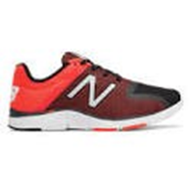 | New Balance, Flimby, Nr Maryport. HQ in Boston, Massachusetts, USA. Many famous people have been spotted wearing New Balance trainers. Opportunity to travel and work/train abroad with this business.

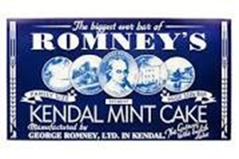 | Kendal Mint Cake, George Romney Ltd, Kendal. Over 100 years old, 4th generation family business. Energy snack of choice for most professional mountaineers, to be found up Everest, Mount Picchu and in Disney‘s Epcot Centre, Florida.

Andrex Toilet Roll, Kimberly-Clark, Barrow in Furness. Employing over 7000 people across Europe, the Middle East and Africa. Opportunities to work on environmental impact - biodegradable products

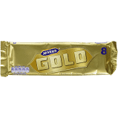 | McVities Gold Bar, McVities, Carlisle. Established in 1831 to produce Carrs Water Biscuits, joined the McVities family in the early 1900‘s. Famous brands include the digestive, jaffa cakes, hobnobs, etc... Budding bakers could join their new product development team.

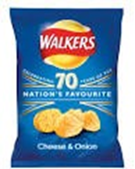 | Walkers Crisps Packaging, Amcor Flexibles UK, Workington. Producing packaging for some of the most well-known products on our supermarket shelves. Are you into graphic design or programming? These two skills combine here to ensure the best designs end up on the cutting- edge packaging foils and films.

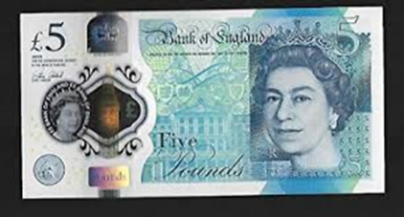 | Five Pound Note, Innovia Films, Wigton. Specialist films produced with specially developed coatings. Those with an aptitude for chemistry can find opportunities here, also given their international reach, second or third languages are welcomed.

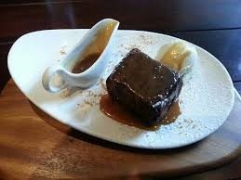 | Cartmel Sticky Toffee Pudding, Cartmel Village Shop, Cartmel. Originally made in the kitchen at the back of the shop, this award winning and still hand-made pudding can be found in Selfridges, Waitrose, Harvey Nichols and Fortnum & Mason. A good example of how a cottage industry can really take off.

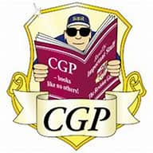 | CGP Books, Broughton in Furness. The UK’s No 1 Educational publisher. You‘ll have come across their revision guides, with a range of 1000+ products and 12million copies sold each year. If you’re an excellent wordsmith this might be the place for you.

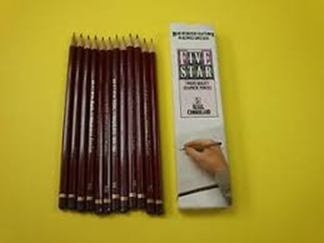 | Cumberland Pencils - now Derwent UK, part of the ACCO Group, Workington. Originally manufactured in Keswick (with graphite mine in nearby Borrowdale) they moved to Workington in 2008. The Pencil Museum still exists in Keswick and provides opportunities to work in tourism, retail and customer service.

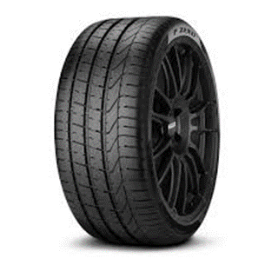 | Pirelli Tyres, Carlisle. Part of the Pirelli Group with Head Office in Italy. Pirelli make tyres for Lamborghini Cars and Ducati motorbikes. Factory in Carlisle employs around 800 people in a variety of roles. These include a state-of-the-art laboratory where chemists develop new tyre compounds for future use.

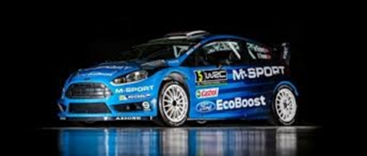 | M Sport, Dovenby, Cockermouth. Established and run by Malcolm Wilson, championship Rally Driver, M Sport manages both the Ford and Bentley Rally Teams. At their base in Dovenby, a test track is under construction, where new technological advances in car building can be tested. Budding car mechanics this is the place for you!

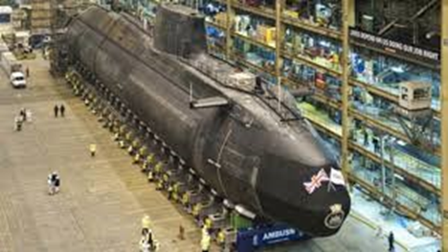 | Nuclear Submarines, BAE Systems, Barrow in Furness. Part of the huge BAE Systems Group and continuing a strong tradition of ship building in Barrow, BAE are now building the next generation of nuclear submarines. Employing a vast number of local people, their apprenticeship and graduate programmes are highly sought after.

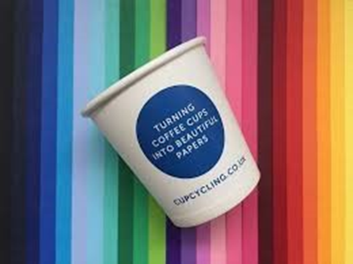 | Paper manufacture, James Cropper Plc, Kendal. A family firm, established some 175 years ago, James Cropper employs around 600 people. It produces high quality paper and wood products, innovating all the time. The picture shows a paper cup, this firm was the first to recycle paper coffee cups, making them into high quality paper and packaging solutions.

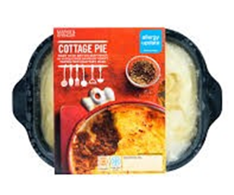 | Marks & Spencer Cumberland Pie, Cavaghan & Gray, Carlisle. Originally a small butchery partnership employing 8 people, Cavvies (as it‘s known locally) is part of the 2 Sisters Food Group now and is one of Carlisle largest employers. Developing new products for the likes of Marks and Spencer and Heinz, if you’re into food and nutrition this might be the place for you?
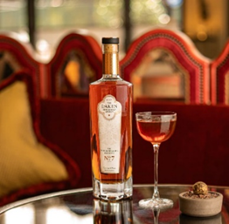 | Lakes Distillery, Nr Bassenthwaite. Opened in December 2014, they produce various gins and whiskeys. They employ a Master blender to develop their unique brands, some of which sell for thousands of pounds. Artisan food and drink producers are in popular demand. Are you interested in the old crafts and trades, they are returning to our economy.

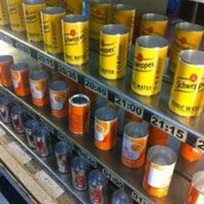 | Can manufacturing, Crown Packaging UK, Carlisle. Affectionately known as Metalbox, this name tells you what the company does. It makes all kinds of shapes and sizes of metal boxes, often with great graphics printed on. Advanced manufacturing techniques are standard here, making it a great place to gather engineering skills.

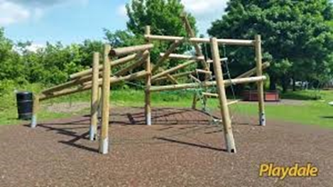 | Playdale play equipment, Playdale Ltd, Ulverston. This is a business that exports it‘s play equipment around the world. Whether in design or installation the travel possibilities are endless!

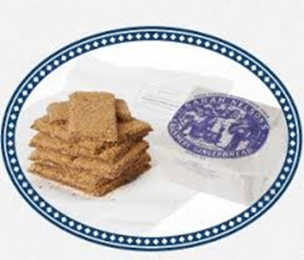 | Grasmere Gingerbread, Grasmere. No surprises here but did you know that this original recipe was first created 160 years ago and still sells from the small cottage in Grasmere where it all began. Most days a queue of tourists can be seen outside the shop waiting to buy this lakes legend. There‘s many opportunities to be found in the tourist industry.

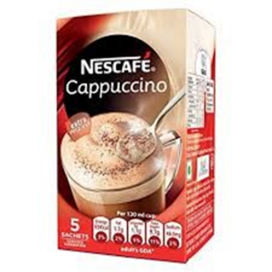 | Nestle Cappuccino, Nestle, Dalston, Nr Carlisle. Nestle is a worldwide brand with a local presence here in Cumbria. Supporting many local dairy farms, it produces powdered milk products such as the instant cappuccino. They offer excellent apprenticeship opportunities.

Beatrix Potter Books, Hawkshead. Beatrix Potter settled in a farm near Hawkshead. Her books are still popular and her story was immortalised in film not so long ago. Are you an avid reader or writer of poetry or fiction? Could you turn this into a career?

Supplied by Inspira – The Link Programme.
Any queries or comments please contact Vicky Ritson, Local Employer Engagement Coordinator. E:vicky.ritson@inspira.org.uk

Inspira Cumbria Limited is a Registered Charity and a Company Limited by Guarantee, Company Registered in England and Wales
No. 4182567. Charity Registration number 1179502. Registered Office: Gillan Way, Penrith 40 Business Park, Penrith, Cumbria, CA11 9BP

t: 01931 711300 e: info@inspira.org.uk www.inspira.org.uk

